7.1.1 Editors - 3D View - Header tools and Options
Detailed Table of content 1
Introduction 11
Mode Drop-down Box 11
Mesh Object Sub Modes 12
Grease Pencil Sub Modes 15
Object settings 21
Lock Camera to View 26
Object Types Visibility 26
Viewport Gizmo 27
Show Overlays - all modes 30
Show Overlays - Mesh Object - Edit Mode 33
Show Overlays - Mesh Object - Sculpt Mode 37
Show Overlays - Mesh Object - Vertex Paint Mode 37
Show Overlays - Mesh Object - Weight Paint Mode 37
Show Overlays - Mesh Object - Texture Paint Mode 38
Show Overlays - Pose Mode 38
Show Overlays - Grease Pencil 38
Viewport Shading 43
Align View Buttons 57
Grease Pencil - all modes - Layer Panel 57
Grease Pencil - Edit mode - Options Panel 59

Detailed Table of content

Detailed table of content
Detailed Table of content 1
Introduction 11
Mode Drop-down Box 11
Object Mode 11
Edit Mode 11
Sculpt Mode 11
Vertex Paint 11
Weight Paint 12
Texture Paint 12
Edit Strokes 12
Particle Edit 12
Draw 12
Mesh Object Sub Modes 12
Edit Mode - Mesh Select Modes 12
Vertex Paint - Mask and Vertex Selection 13
Paint Mask 13
Vertex Selection 13
Weight Paint - Mask and Vertex Selection 13
Paint Mask 14
Vertex Selection 14
Texture Paint - Mask Selection 14
Paint Mask 14
Particle Edit - Select Modes 15
Mesh Object with a particle system. You can just have one method active at a time. 15
Path 15
Point 15
Tip 15
Grease Pencil Sub Modes 15
Edit Mode 15
Select Modes 15
Select Only Points 15
Select all Stroke Points 15
Select all Stroke Points between other strokes 16
Curve Editing 16
Curve Editing panel 16
Curve Resolution 16
Threshold 16
Corner Angle 16
Adaptive Resolution 16
Multi frame 16
Use Falloff 16
Interpolate Panel 16
Interpolate 16
Sequence 17
Remove Breakdowns 17
Options 17
Interpolate All Layers 17
Interpolate Selected Strokes 17
Sequence options 17
Step 17
Type 17
Curve panel 17
Adding Points 17
Navigation elements 17
Zoom in and out 17
Tools 18
Reset View 18
Vector Handle 18
Auto Handle 18
Auto Clamped Handle 18
Reset Curve 18
Use Clipping 18
Delete Points 18
Easing 18
Back 18
Amplitube + Period 18
Amplitube 18
Period 18
Sculpt Mode 19
Selection Mask 19
Multi frame 19
Use Falloff 19
View 19
Draw Mode 19
Origin 19
View 19
Use Guides 20
Circular 20
Radial 20
Angle 20
Parallel 20
Grid 20
Isometric 20
Use Snapping 20
Spacing 20
Reference Point 20
Draw Strokes on Back 20
Add Weight Data for new strokes 20
Use Additive Drawing 20
Automerge 21
Weight Paint Mode 21
Multi frame 21
Use Falloff 21
Object settings 21
Transform Orientations 21
View 21
Gimbal 21
Normal 22
Local 22
Global 22
Cursor 22
Create Orientation 22
Last Operator Create Orientation 22
Name 22
Use View 22
Use after creation 22
Overwrite Previous 22
Pivot Point 22
Only Origins 23
Snapping 23
Multiple Snap Targets 23
Snapping 23
Increment 23
Vertex 23
Edge 23
Face 23
Volume 23
Edge Center 24
Edge Perpendicular 24
Snapping Settings 24
Absolute Grid Snap 24
Snap Target 24
Closest 24
Center 24
Median 24
Active 24
Back face Culling 24
Project Onto Self 24
Align Rotation to Target 24
Project Individual Elements 25
Snap Peel Object 25
Affect 25
Proportional Editing 25
Settings 25
Proportional Size 25
Last Operator Proportional Editing 25
Proportional Editing 25
Proportional Falloff 26
Proportional Size 26
Connected 26
Projected(2D) 26
Lock Camera to View 26
Object Types Visibility 26
Viewport Gizmo 27
Show Gizmo 27
Gizmo Options 27
Viewport Gizmos 27
Navigate 27
Navigation Controls 27
3D Viewport Axis 27
Off 27
Simple Axis 27
Interactive Navigation 27
Active Tools 28
Active Object 28
Object Gizmos 28
Transformation Orientation 28
Move 28
Rotate 28
Scale 28
Empty 28
Image 28
Force Field 29
Light 29
Size 29
Look At 29
Camera 29
Lens 29
Focus Distance 29
Show Overlays - all modes 30
Guides 30
Grid 30
Floor 30
Axes 30
Scale 30
Subdivisions 30
Options 30
Text Info 30
Annotations 30
Statistics 31
3D Cursor 31
Objects 31
Extras 31
Relationship Lines 31
Outline Selected 31
Bones 31
Motion Paths 31
Origins 31
Origins(All) 32
Geometry 32
Wire frame 32
Wireframe Threshold 32
Opacity 32
Face Orientation 32
Fade inactive Geometry 32
Motion Tracking 32
Camera Path 33
Marker Names 33
Track display type 33
Track size 33
Show Overlays - Mesh Object - Edit Mode 33
Mesh Edit Mode 33
Edges 33
Faces 33
Center 33
Creases 33
Sharp 33
Bevel 33
Seams 34
Developer 34
Indices 34
Shading 34
Hidden Wire 34
Vertex Groups Weights 34
Zero Weights 34
None 34
Active 34
All 34
Mesh Analysis 34
Overhang 34
Minimum/Maximum 34
Axis 35
Thickness 35
Minimum/Maximum 35
Samples 35
Intersections 35
Distortion 35
Minimum/Maximum 35
Sharp Edges 36
Minimum/Maximum 36
Measurement 36
Edge Length 36
Edge Angle 36
Face Area 36
Face Angle 36
Normals 36
Size 36
Freestyle 37
Edge Marks 37
Face Marks 37
Show Overlays - Mesh Object - Sculpt Mode 37
Show Mask 37
Show Face Sets 37
Show Overlays - Mesh Object - Vertex Paint Mode 37
Opacity 37
Show Wire 37
Show Overlays - Mesh Object - Weight Paint Mode 37
Opacity 37
Zero Weights 37
None 37
Active 38
All 38
Show Weight Contours 38
Show Wire 38
Show Overlays - Mesh Object - Texture Paint Mode 38
Stencil Opacity 38
Show Overlays - Pose Mode 38
Show Bone X Ray 38
Opacity 38
Show Overlays - Grease Pencil 38
In Object Mode 38
Onion Skin 38
Canvas 39
Canvas X Ray 39
Fade Layers 39
Fade Objects 39
Fade Grease Pencil Objects 39
In Edit Mode 39
Onion Skin 39
Canvas 39
Canvas X Ray 39
Fade Layers 40
Fade Objects 40
Fade Grease Pencil Objects 40
Edit Lines 40
Stroke Direction 40
Only in multi frame 40
Material Name 40
Vertex Opacity 40
In Sculpt and Weight paint Mode 40
Onion Skin 40
Canvas 40
Canvas X Ray 41
Fade Layers 41
Fade Objects 41
Fade Grease Pencil Objects 41
Edit Lines 41
Only in multi frame 41
Vertex Opacity 41
In Draw Mode 41
Onion Skin 41
Canvas 41
Canvas X Ray 41
Fade Layers 42
Fade Objects 42
Fade Grease Pencil Objects 42
Vertex Opacity 42
In Vertex Paint mode 42
Onion Skin 42
Canvas 42
Canvas X Ray 42
Fade Layers 42
Fade Objects 43
Fade Grease Pencil Objects 43
Edit Lines 43
Only in multi frame 43
Vertex Opacity 43
Opacity 43
Viewport Shading 43
Show X Ray 43
Viewport Shading 43
Wire frame 43
Solid 43
Material 43
Rendered 44
Viewport Shading Settings 44
Viewport Shading Settings with Wire frame 44
Color 44
Single 44
Object 44
Random 44
Background 44
Theme 44
World 44
Viewport 44
Options 44
Show X Ray 44
X Ray Alpha 45
Outline 45
Outline Color 45
Viewport shading Settings with Solid 45
Lighting 45
Studio 45
World Space Lighting 45
Rotation 45
Show Light Preferences 45
Color 46
Material 46
Object 46
Vertex 46
Single 46
Random 46
Texture 46
Background 46
Theme 46
World 46
Viewport 46
Options 46
Back face Culling 46
Show X Ray 47
X Ray Alpha 47
Shadow 47
Shadow Intensity 47
Light Settings 47
Light Direction 47
Shadow Shift 47
Shadow Focus 47
Cavity 47
Type 47
World 47
World Space / Ridge Valley 47
Shading Options 47
Screen 48
Screen Space / Ridge Valley 48
Both 48
Depth of Field 48
Outline 48
Outline Color 48
Specular Lighting 48
Matcap 48
Show Light Preferences 49
Flip Matcap 49
Color 49
Material 49
Object 49
Vertex 49
Single 49
Random 49
Texture 49
Background 49
Theme 49
World 49
Viewport 50
Options 50
Back face Culling 50
Show X Ray 50
X Ray Alpha 50
Shadow 50
Shadow Intensity 50
Light Settings 50
Light Direction 50
Shadow Shift 50
Shadow Focus 50
Cavity 51
Type 51
World 51
World Space / Ridge Valley 51
Shading Options 51
Screen 51
Screen Space / Ridge Valley 51
Both 51
Outline 51
Outline Color 51
Specular Lighting 51
Flat 51
Color 52
Material 52
Object 52
Vertex 52
Single 52
Random 52
Texture 52
Background 52
Theme 52
World 52
Viewport 52
Options 52
Back face Culling 52
Show X Ray 52
X Ray Alpha 53
Shadow 53
Shadow Intensity 53
Light Settings 53
Light Direction 53
Shadow Shift 53
Shadow Focus 53
Cavity 53
Type 53
World 53
World Space / Ridge Valley 53
Shading Options 53
Screen 53
Screen Space / Ridge Valley 54
Both 54
Outline 54
Outline Color 54
Specular Lighting 54
Viewport Shading with Material Preview 54
Lighting 54
Scene Lights 54
Scene World 54
hdr file browser 54
Show light preferences 55
World Space Lighting 55
Rotation 55
Background 55
World Opacity 55
Blur 55
Viewport Shading with Rendered 55
Lighting 55
Scene Lights 55
Scene World 55
Studiolight Preview 56
Show Light preferences 56
Rotation 56
Strength 56
World Opacity 56
Blur 56
Render Pass 56
Pause Preview 56
Align View Buttons 57
Align View Buttons 57
Grease Pencil - all modes - Layer Panel 57
Layer list 57
Layer name 57
Mask Layer 57
Onion Skinning 57
Viewport/Render Visibility 57
Lock 57
Search Field 57
Add new layer 58
Remove layer 58
Layer Specials 58
Duplicate Layer 58
Duplicate Empty Keyframes 58
Show All 58
Hide Others 58
Lock All 58
Unlock All 58
Autolock inactive layer 58
Merge Down 58
Copy Layer to Object 58
Isolate Layer 58
Isolate Layer 59
Blend 59
Opacity 59
Use Lights 59
Grease Pencil - Edit mode - Options Panel 59
Scale Stroke Thickness 59

Introduction

The header in the 3D view contains various menus and tools. This chapter here is about the tools, modes and options elements in the header.

The text menus are covered in a own chapter each. They vary too much, dependent of mode and object type.

Mode Drop-down Box

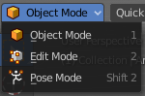
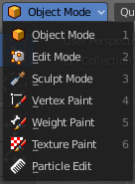
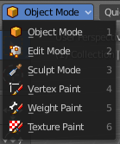
The Mode drop-down box allows you to switch between the different modes.

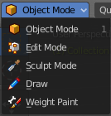
Modes are object states that allows you to edit and manipulate objects at different levels with different tool sets and goals. The sculpt mode for example allows you to sculpt a mesh object. Edit Mode allows to manipulate the mesh of the object, and so on.

The available modes can differ from object to object. An armature for example has an additional pose mode. And when you work with a grease pencil object, then several grease pencil modes becomes available.

Object Mode
This mode allows to manipulate objects at Object level. Like move it around, rotate it, etc. This mode is available for all object types.

Edit Mode
The edit mode allows to edit the object. With a mesh object this means that you are able to modify and to change the geometry. With an armature you build your skeleton. And with a text object you can type in text, and choose the font etc.
Not all objects has an edit mode.

Sculpt Mode
In this mode you can sculpt the mesh. This mode is available for mesh and grease pencil objects.

Vertex Paint
Vertex Paint is a mesh object only mode. In this mode you can paint vertices with colors.

Weight Paint
In this mode you can adjust weight painting for an armature for example. But Weight Painted mesh objects can also be used in conjunction with particles. Also a grease pencil stroke can be weight painted.

Texture Paint
Weight Paint is a mesh object only mode. In this mode you can paint at the texture of a mesh directly. This mode requires to have a working UV mapping and a texture at the mesh object.

Edit Strokes
Edit Strokes is a Grease Pencil only mode. It allows to manipulate the curves at a mesh level.

Particle Edit
Particle edit is a Particle System mode only. When you apply a particle system to a mesh object then this mode becomes available. It allows you to manipulate the particle system at a mesh level. You can comb hair particles for example.

Draw
Draw is a grease pencil object only mode. In this mode you draw grease pencil strokes.

Mesh Object Sub Modes

The different modes can have some sub modes. For example different selection methods in mesh edit mode. Or a mask mode for texture painting. The sub mode settings can be found right from the Modes drop down box.

Edit Mode - Mesh Select Modes
When you enter the edit mode with a mesh object then you will see the mesh select modes. They allows you to switch between the three available selection modes Vertice select, Edge Select and Face Select.

Vertex Select allows you to select vertices.
Edge Select allows you to select edges.
Face select allows you to select faces.

The mesh display changes, dependent of the mode. When you have for example select vertices active, then the vertices highlights at the mesh.

You can have more than one mode active by shift clicking at the other mesh select modes.
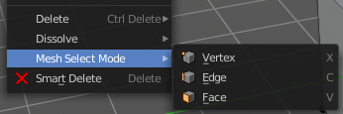
The standard Bforartists has hotkeys to switch between the modes. X, C and V. You cannot see or edit them at the header element. There is however a sub menu in the mesh menu, called Mesh Select Mode. Here you can see and edit the hotkeys.

Vertex Paint - Mask and Vertex Selection

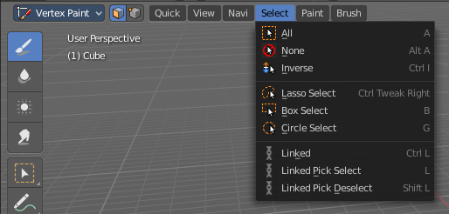
Paint Mask
When you activate this tool then you reveal a Select menu in the header. And you can select the mesh parts that you want to manipulate. Note that you may first want to deselect all. By default everything is selected ...

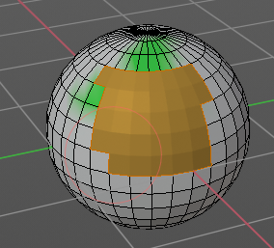
The select menu is explained in the chapter Vertex Paint modes. The menu items should be pretty self explaining though.

When you have selected a part of the mesh, then you can just paint the faces at this selected part. The edges are the border.

Vertex Selection
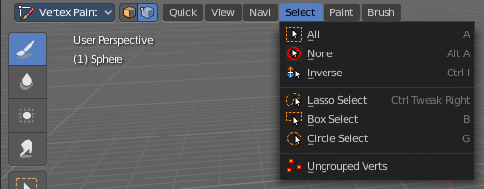
When you activate this tool then you reveal a Select menu in the header. And you can select the mesh parts that
You want to manipulate. This tool is meant for Weight Painting. And so the mesh displays the vertices too.
Note that you may first want to deselect all. By default everything is selected ...

The select menu is explained in the chapter Vertex Paint modes. The menu items should be pretty self explaining though.

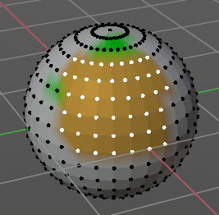
When you have selected a part of the mesh, then you can just paint the vertices at this selected part. The difference to the Paint mask method is that here the edges are not the border of the color. But there is a gradient between the vertices.

Weight Paint - Mask and Vertex Selection

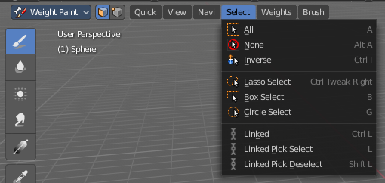
Paint Mask
Mesh Object.
When you activate this tool then you reveal a Select menu in the header. And you can select the mesh parts that you want to manipulate. Note that you may first want to deselect all. By default everything is selected ...

The select menu is explained in the chapter Vertex Paint modes. The menu items should be pretty self explaining though.

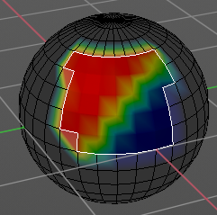
When you have selected a part of the mesh, then you can just paint the faces at this selected part. The edges are the border.

Vertex Selection
Mesh Object.
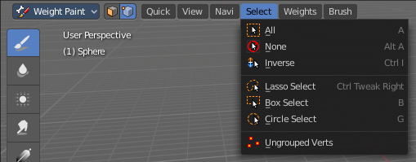
When you activate this tool then you reveal a Select menu in the header. And you can select the mesh parts that
You want to manipulate. This tool is meant for Weight Painting. And so the mesh displays the vertices too.
Note that you may first want to deselect all. By default everything is selected ...

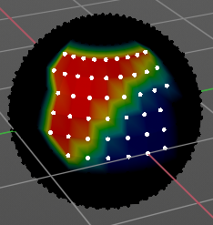
The select menu is explained in the chapter Vertex Paint modes. The menu items should be pretty self explaining though.

When you have selected a part of the mesh, then you can just paint the vertices at this selected part. There is no real difference to the faces method. The selection is the same.

Texture Paint - Mask Selection

Paint Mask
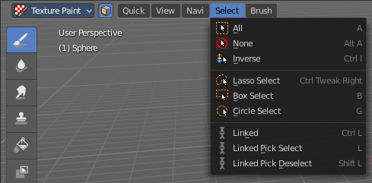
Mesh Object.
When you activate this tool then you reveal a Select menu in the header. And you can select the mesh parts that you want to manipulate. Note that you may first want to deselect all. By default everything is selected ...

The select menu is explained in the chapter Vertex Paint modes. The menu items should be pretty self explaining though.

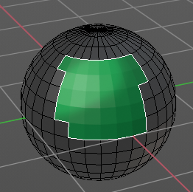
When you have selected a part of the mesh, then you can just paint the faces at this selected part. The edges are the border.

Particle Edit - Select Modes

Mesh Object with a particle system. You can just have one method active at a time.

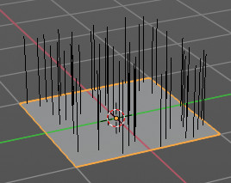
Path
No key points are visible, you can select/deselect only all particles.

Point
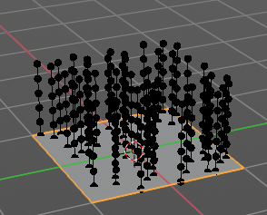
You can see, select and edit all key points of the particle paths.

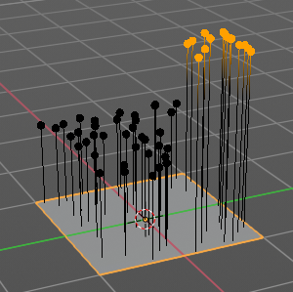
Tip
You can only see, select and edit the tip of the particles. This includes the brushes. The comb brush is a special case here. The other pat key points bends of course still in this mode. But affected by the brush is just the tip key.

Grease Pencil Sub Modes

The different modes can have some sub modes. For example different selection methods in mesh edit mode. Or a mask mode for texture painting. The sub mode settings can be found right from the Modes drop down box.

Edit Mode
The edit mode allows you to edit the grease pencil strokes.

Select Modes
You can only have one method active at a time.

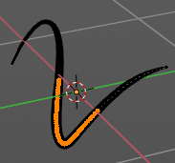
Select Only Points
When you for example border select some points of the stroke, then just this points gets selected.

Select all Stroke Points
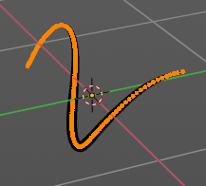
When you for example border select some points of the stroke, then the whole stroke gets selected.

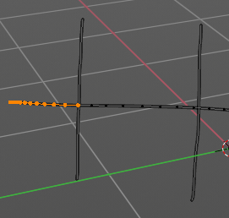
Select all Stroke Points between other strokes
When you for example border select some points of the stroke, and this stroke crosses another stroke, then the part of the stroke up to the crossing point gets selected.

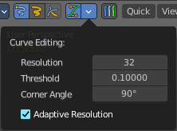
Curve Editing
Edit Strokes by using Curve handles.

Curve Editing panel
The settings for Curve Editing.

Curve Resolution
Number of segments generated between control points

Threshold
The curve conversion error threshold

Corner Angle
Angle threshold to be treaten as corners. The resolution is the number of points generated per unit distance.

Adaptive Resolution
Set the resolution for each segment dynamically based on its length.

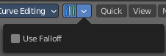
Multi frame
When this mode is active, then you can edit strokes from multiple grease pencil frames at once. The key frames must be selected to be included.

Use Falloff
Multi frame has a setting, which becomes visible when the mode is active.
Use Falloff when edit in Multi frame mode to compute brush effect by frame.

Interpolate Panel
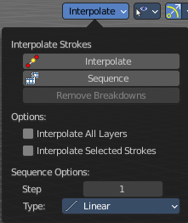
When you are animating simple shapes you can use the interpolate tools to automatically add new breakdown key frames.

Interpolate
Interpolates strokes between the previous and next key frame by adding a single key frame. When you are on a frame between two key frames and click the Interpolate button a new breakdown key frame will be added. This way you define the final interpolation for the new stroke.

Sequence
Interpolate strokes between the previous and next key frame by adding multiple key frames. When you are on a frame between two key frames and click the sequence button a breakdown key frame will be added on every frame between the previous and next key frame.

Remove Breakdowns
Removes the breakdowns generated by the interpolate tool. When there is no breakdown pose then the button is greyed out.

Options

Interpolate All Layers
When enabled, interpolated key frames will be created on all layers, not only the active one.

Interpolate Selected Strokes
When enabled, only selected strokes will be interpolated.

Sequence options

Step
Number of frames between generated interpolated frames.

Type
Interpolation method to use for the sequence.

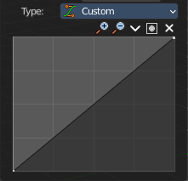
Curve panel
With interpolation type Custom. Here you can set up a custom interpolation curve.

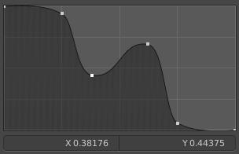
Adding Points
You can add new curve points by simply left clicking at the curve. Move the mouse to position them where you need it.

Navigation elements
The navigation elements at the top are described from left to right.

Zoom in and out
The two buttons with the magnifying glass at it zooms in and out in the curve window.

Tools
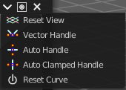
Tools is a menu where you can find some curve related tools.

Reset View
Resets the curve windows zoom.

Vector Handle
Set handle type to Vector.

Auto Handle
Set handle type to Auto.

Auto Clamped Handle
Set handle type to Auto Clamped.

Reset Curve
Resets the curve to the initial shape.

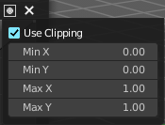
Use Clipping
Clipping options. Set up clipping for the stroke. The blue button at the top turns clipping on or off.

Delete Points
Deletes the selected curve point.

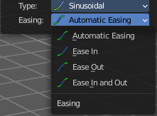
Easing
With the easing interpolation methods.
The easing methods are self explaining.

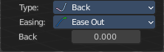
Back
With interpolation method Back.
The amount of overshoot for back easing.

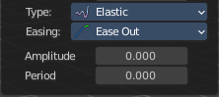
Amplitube + Period
With interpolation method Elastic.

Amplitube
Amount to boost elastic bounces for elastic easing.

Period
Time between bounces for elastic easing.

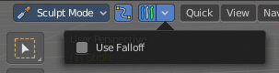
Sculpt Mode
The sculpt mode allows you to sculpt the grease pencil strokes.

Selection Mask
When you activate this mode, then just the selected parts gets sculpted.

Multi frame
When this mode is active, then you can edit strokes from multiple grease pencil frames at once. The key frames must be selected to be included.

Use Falloff
Multi frame has a setting, which becomes visible when the mode is active.
Use Falloff when edit in Multi frame mode to compute brush effect by frame.

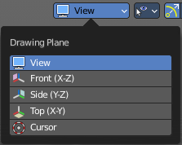
View
Relative to which plane to draw the strokes. Default orientation is view.

Draw Mode
The draw mode is the mode in which you draw the grease pencil strokes.

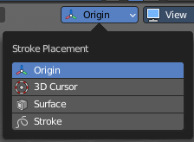
Origin
Where the stroke is placed.

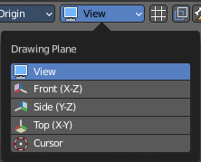
View
Relative to which plane to draw the strokes. Default orientation is view.

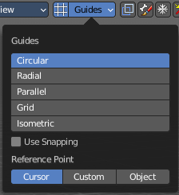
Use Guides
Guides allows you to draw geometric shapes with the grease pencil.

Circular
Draw a circle arround the origin.

Radial
Draw a straight line through the origin.

Angle
Doesn't do anything.

Parallel
Draw parallel horizontal lines.

Grid
Draw parallel horizontal and vertical lines.

Isometric
Draw parallel lines in an specific angle.

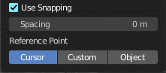
Use Snapping
Enable snapping to guides angles or spacing options.

Spacing
The guide spacing. This is the distance between the strokes.

Reference Point
What point to use as the reference for the strokes.

Draw Strokes on Back
Usually a new stroke is drawn on top of existing strokes. Draw Strokes on Back adds the new strokes below the existing strokes.

Add Weight Data for new strokes
Add Weight data for new strokes, according to the current vertex group and weight. When no vertex group is selected, then no weight is added.

Use Additive Drawing
When creating new frames, then the strokes from the previous or active frame gets included as the base for the new stroke.

Automerge
Join last drawn strokes by distance with previous strokes in the active layer.

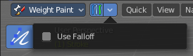
Weight Paint Mode

Multi frame
When this mode is active, then you can edit strokes from multiple grease pencil frames at once. The key frames must be selected to be included.

Use Falloff
Multi frame has a setting, which becomes visible when the mode is active.
Use Falloff when edit in Multi frame mode to compute brush effect by frame.

Object settings

The object settings just appears when the Tool Settings are hidden. This can be done in the View menu.
Parts of the object settings are just visible in Object and Edit Mode. Parts in other modes.

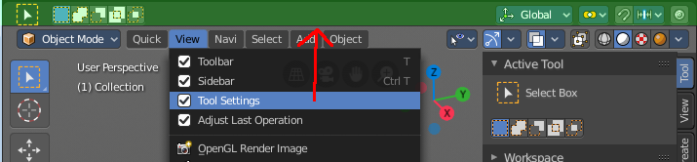

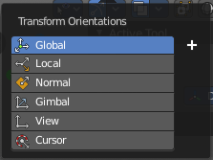
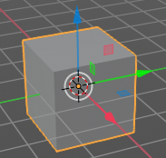
Transform Orientations
You can display Transform Manipulators at your object or selection by activating them in the tool shelf. They allow you to scale, rotate or move objects by grabbing their controls, and moving your mouse in the corresponding axis. The widget can be oriented in different ways by using another method in this drop down box. The names should be self explaining.

View
The transform orientation aligns to the current view.

Gimbal
Aligns each axis to the Euler rotation axis as used for input.

Normal
This is of interest for bones for example. Aligns the transformation axis to average normal of the selected elements. Bone Y axis for Pose mode.

Local
Uses the local orientation of the selected elements.

Global
Uses the global orientation for the selected elements.

Cursor
Uses the orientation of the 3D cursor.

Create Orientation
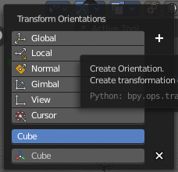
The create orientation button at the right adds a new orientation from the current mode and view. You can rename it.

This view is scene specific only. It does save and load with the current scene. But you cannot transfer it into another scene. When you create a new scene then this custom orientation is gone.

You can create more than one user orientation.

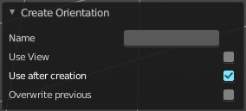
Last Operator Create Orientation
Create Orientation has some settings.

Name
Rename the orientation.

Use View
Use the current view instead of the active object to create the new orientation.

Use after creation
Use this orientation after creation.

Overwrite Previous
Overwrite previous created orientation in case it has the same name.

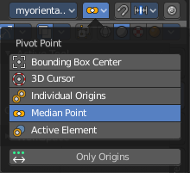
Pivot Point
The Pivot Point is the center of your object or your selection. When you rotate or scale an object, or a group of vertices/edges/faces, you may want to shift the pivot point in 3D space. The names should be self explaining.

Only Origins
When this option is enabled, then the transformation will change the positions of the object’s origins, but will not affect the object itself.

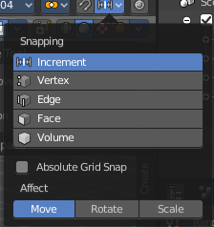
Snapping
Activate snapping when transforming an element.
Snapping can be temporarily activated by holding CTRL key. So no need to turn snapping on and off all the time.
You can snap to various scene elements in Object, Edit and Pose mode. And you can activate more than one snapping method by holding down CTRL and clicking at the next snapping element.

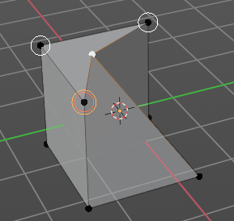
Multiple Snap Targets
When you move the mouse with snapping on and the element to snap selected (This does not work with holding Ctrl), then you can press hotkey A to mark the current snapping point, then proceed to mark as many other snapping points as you wish. And the element that you want to snap will then be in the center of these marked snapping points. Marked snapping points will have a circle around.
Marking a point more than once will give it more weight in the averaged location.

Snapping

Increment
Incremental grid snapping. In Orthographic view the snapping increment changes depending on zoom level.

Vertex
Snap to a vertice.

Edge
Snap to an edge.

Face
Snap to a face.

Volume
Snaps to regions within the volume of the first object found below the mouse cursor.

Edge Center
Snaps to the center of an edge.

Edge Perpendicular
Snap to the nearest point of an edge.

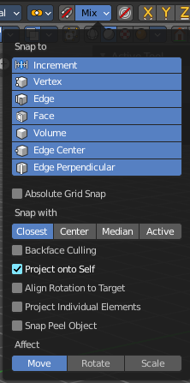
Snapping Settings
Define to which other elements the current active element should snap to. The names should be self explaining. Increment snaps by a grid unit.
Some snapping methods reveals further snapping options.

Absolute Grid Snap
Available only for the increase option. Snap to grid, instead of snapping in increments relative to the current location.

Snap Target
Snap target options become active when either Vertex, Edge, Face, or Volume is selected as the snap element. These determine what part of the selection snaps to the target objects.

Closest
Moves the closest point of the selection to the target.

Center
Moves the current transformation center to the target. Can be used with 3D cursor to snap with an offset.

Median
Moves the median of the selection to the target.

Active
Moves the active element (vertex in Edit Mode, object in Object Mode) to the target.

Back face Culling
Exclude back facing geometry from snapping.

Project Onto Self
Available only in editing mode for Vertices, Edges, Faces and Volume. Snaps elements to its own mesh.

Align Rotation to Target
Available for Vertices, Edges, Faces and Volume. When the Snap Affects Rotation, this align rotation with the snapping target.

Project Individual Elements
Available for snap to Faces. Project individual elements on the surface of other objects.

Snap Peel Object
Available for snap to Volume. Consider Objects as whole when finding volume center.

Affect
Adjust what transform methods should be affected by snapping.

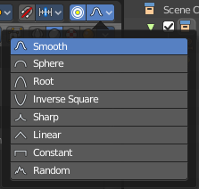
Proportional Editing
Enables proportional editing.
Proportional Editing is a way of transforming selected elements (such as vertices) while having that transformation affect other nearby elements with a falloff. For example, moving a single vertex will move unselected vertices within a given range. And the falloff means that selected vertices that are closer to the selected vertex will move more than those farther from it.

Settings
The settings appears when you activate Proportional Editing. Choose between different falloff methods for the proportional editing.

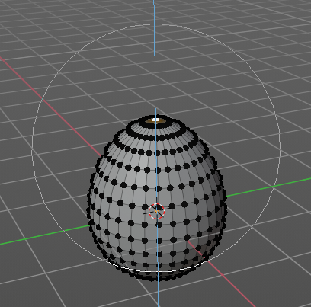
Proportional Size
The influence of the proportional editing is defined by a radius. It is by default one standard unit.
You can change the influence radius for proportional editing with the mouse wheel or the Page up Page down arrows while keeping the mouse button pressed down and do the translation.

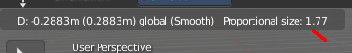
The exact radius value can be read in the header while transformation.

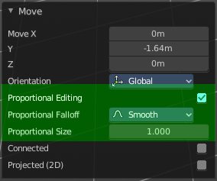
Last Operator Proportional Editing

When you translate an object, move it around or rotate or scale it, then the last operator contains also proportional editing settings.

Proportional Editing
Enable proportional editing.

Proportional Falloff
Adjust the falloff methods again.

Proportional Size
Adjust the falloff radius. Note that the white circle is not displayed when using this slider.

Connected
The proportional falloff gets calculated for connected parts only.

Projected(2D)
In depth direction along the view the radius is ignored. It selects as deep as there is something to select.

Lock Camera to View
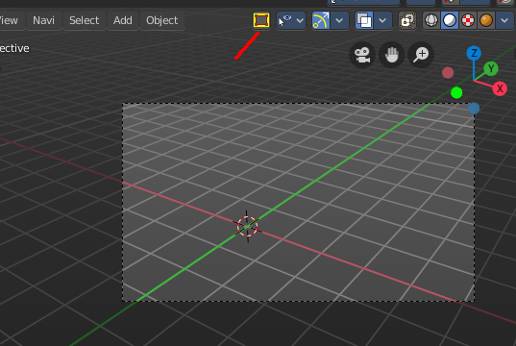
This setting just appears when you are in camera view.

With camera to view activated you can navigate in the camera view
With camera to view activated you can navigate the passepartout, the Grey area around the camera view. You can scale it bigger and move it around.

Object Types Visibility
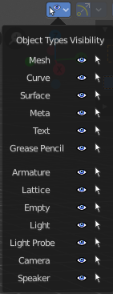
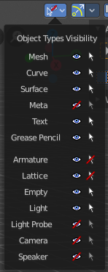
In this drop down box you can set specific elements in the scene to either not selectable or invisible.

When the elements are invisible then they are also not selectable.

When you have set some objects to not selectable or invisible, then the icon in the menu header changes.

Viewport Gizmo
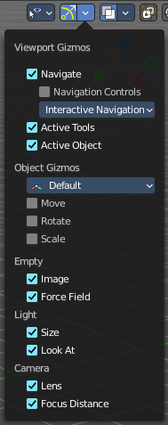
This menu allows you to adjust what gizmos shows. The button at the left turns off or on all of them.

Show Gizmo
Shows or hides all available gizmos at once.

Gizmo Options
Turn on or off specific widgets.

Viewport Gizmos

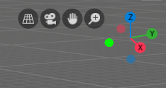
Navigate
Turn on or off the navigate widget. The navigate gizmo is the block of buttons and the widget up right.

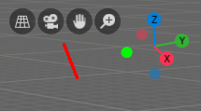
Navigation Controls
Display the navigation controls in the 3D view.

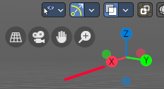
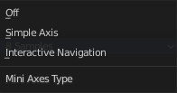
3D Viewport Axis
Adjust the apperance of the 3D Viewport mini axis widget.

Off
Hides the Mini axis widget.

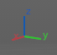
Simple Axis
Shows simple axis. This widget type is not interactive. It just shows the state of the viewport rotation.

Interactive Navigation
The default mini axis widget. This widget is interactive. Clicking and dragging will rotate the viewport. Clicking at one of the colored spots at the end of the axis will snap to the neares orthographic view.

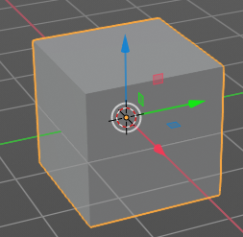
Active Tools
Turn on or off the active tool widget. When you activate one of the transformation buttons in the tool shelf, then a gizmo will appear at the object.

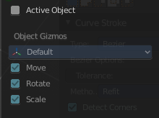
Active Object
Turn on or off the Object Gizmos. The Object Gizmos is an extra set of translate gizmos, similar to the active tool widget that shows when you activate one of the transform buttons in the tool shelf. But it shows permanent as long as you don't have another tool selected that overrides this widget.

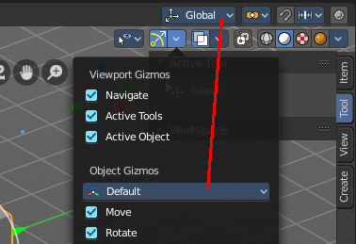
Object Gizmos

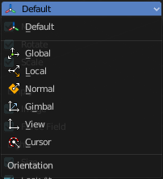
Transformation Orientation
Adjust the orientation of the widget. By default it uses the transform orientation from the viewport. This set can override the transform orientation.
You can have all transform methods on at once.

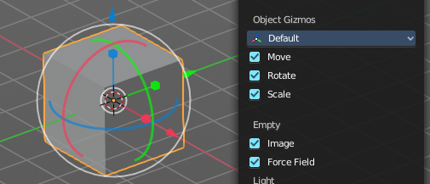
Move
Shows the move part of the widget.

Rotate
Shows the rotate part of the widget.

Scale
Shows the scale part of the widget.

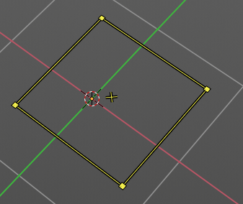
Empty

Image
Shows the transform gizmo at an empty of type Image. You need to hover with the mouse over the object to reveal the yellow gizmo.

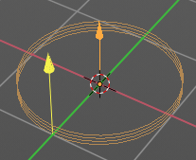
Force Field
Some force field types have a gizmo. Shows the transform gizmo at a force field.

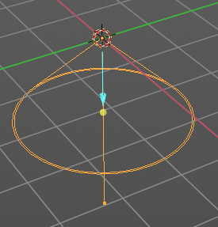
Light

Size
Show the gizmo to adjust the size of lights. That's the blue arrow here.

Look At
Show the gizmo to adjust the direction of the light. That's the yellow dot in the middle of the circle.

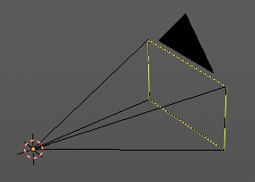
Camera

Lens
Show the gizmo to adjust the lens and orthographic size. The yellow square.

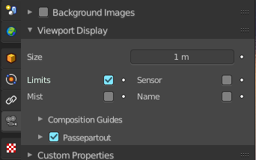
Focus Distance
Show to gizmo to adjust the focus distance.
You first need to turn on the Limits gizmo in the camera settings in the Viewport Display panel. Then you can turn off the focus distance gizmo part with Focus Distance.
Note that this feature is currently broken!

Show Overlays - all modes
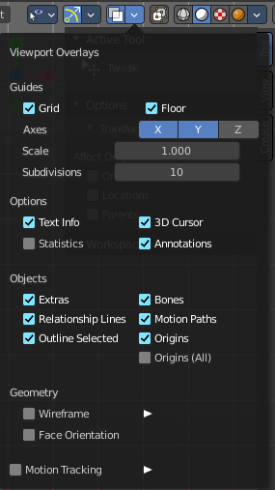
Turn on or off all overlays. This includes the ground grid, things like relationship lines, and several other elements in the viewport. Some content is available in all modes. Some content is changing, dependent of the mode you are in. In Edit mode with a mesh object you will get some normal functionality for example.

Guides

Grid
Show grid in the orthographic views. When you are in perspectivic view, then this feature is greyed out.

Floor
Show the ground grid in the perspectivic views.

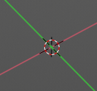
Axes
Show the colored axis lines in the 3d view. This feature just works in perspectivic view. In orthographic view this lines cannot be hidden separately.

Scale
Scale the ground grid. This works in perspectivic and orthographic view.

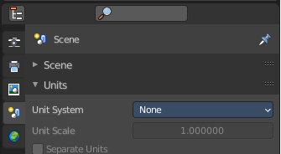
Subdivisions
Subdivisions just shows with a Unit system of None. It allows you to subdivide the ground grid.

Options

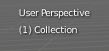
Text Info
In the upper left corner of the 3D view there is a text info string, which can be hidden here. It tells you in what view you are, what is selected, and things like frames per second when you play an animation

Annotations
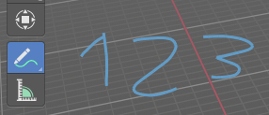
Show or hide annotations. Annotations can be drawn at the 3D View with the annotation tool in the tool shelf.

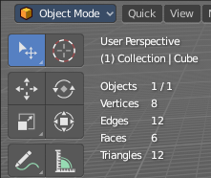
Statistics
Displays statistical informations in the upper left corner of the 3d viewport. Object count, vertices, and so on.

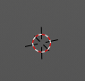
3D Cursor
Show or hide the 3D cursor. That's the white red circle in the center of the viewport.

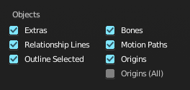
Objects

Extras
Show or hide object details. Including things like empty wires like lights, cameras, and other visual guides.

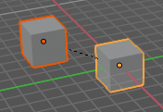
Relationship Lines
Show or hide relationship lines. When you for example parent one object to another then you will see a dotted line. The relationship line.

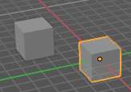
Outline Selected
Show the selected object with an outline

Bones
Show or hide bones.

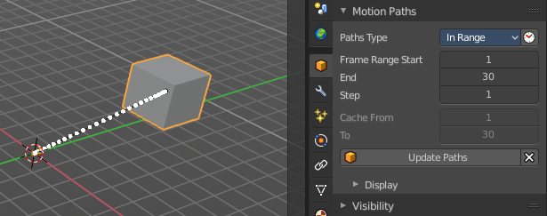
Motion Paths
Show or hide motion paths. Motion paths can be calculated in the Motion Paths panel. You need an animation for that.

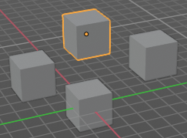
Origins
Show or hide the origin of the selected object. The origin is the center point of the object, and represented by an orange dot.

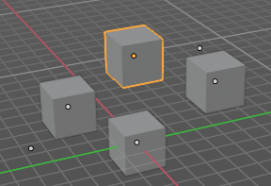
Origins(All)
Show or hide the origin of all objects. Even from hidden ones. The not selected objects shows the center point with a white dot.

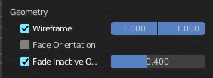
Geometry
Geometry related settings.

Wire frame
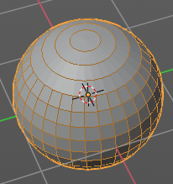
Show the wire frame in object mode.

Wireframe Threshold
With a wire frame value of 1 all edges are drawn. The lower the value, the more edges will disappear.

Opacity
The opacity of the displayed edges.

Face Orientation
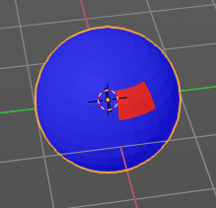
This mode allows to check for faces with flipped normals, which cannot be seen with the defaults. Blue is pointing outwards, red is pointing inwards.

Fade inactive Geometry
Edit mode feature. Fades the not active geometry, the not selected scene objects, towards a plain grey. In Object mode this setting has no effect.
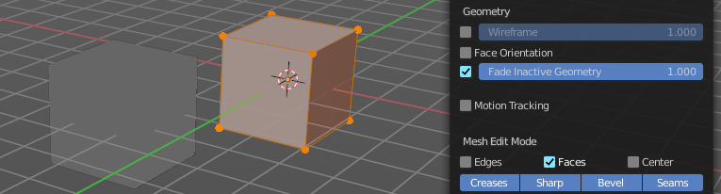

Motion Tracking
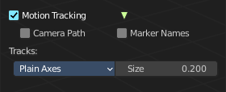
Motion tracking related settings. When you turn it on, then some further options appears. These features just shows before you bake the solution. Not with the resolved solution.

Camera Path
Shows the camera path.

Marker Names
Shows the marker names.

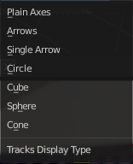
Track display type
How to display the tracks.

Track size
Adjust the display size of the tracks of reconstructed data.

Show Overlays - Mesh Object - Edit Mode

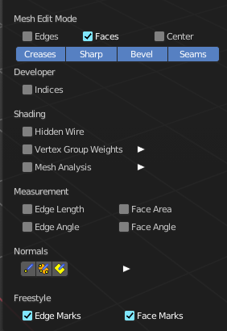
The Show overlays panel shows different content, dependent of mode and object type. This is with mesh object in edit mode.

Mesh Edit Mode

Edges
Highlight selected and partially selected edges.
This only affects vertex and face selection mode (as edges are always highlighted in edge-selection mode).

Faces
Highlight faces by using a face overlay that applies to both selected and unselected faces.
This affects all selection modes.

Center
Show face-center points in solid shading modes.
Only affects face-select mode.

Creases
Display edges marked with a crease for the Subdivision Surface Modifier.

Sharp
Display sharp edges, used with the edge split modifier.

Bevel
Display weights created for the Bevel Modifier.

Seams
Display the UV unwrapping seams.

Developer

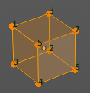
Indices
Display the indices of selected vertices, edges and faces at the mesh.

Shading

Hidden Wire
Show only front-facing wire frames.

Vertex Groups Weights
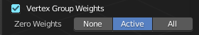
Display weights in Edit Mode. When you activate this feature then further options appears.

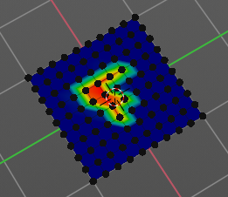
Zero Weights

None
Don't show the vertices with zero weights with a specific color. They appear blue like vertices with a very low weighting.

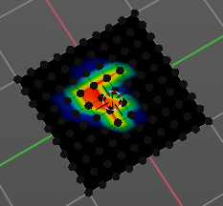
Active
Zero weights vertices are shown with a black color in the active vertex group.

All
Zero weights vertices are shown with a black color in all vertex groups of the mesh.

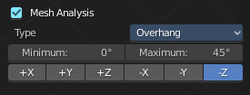
Mesh Analysis
Show the mesh analysis overlay and settings. Note that editing may be slow with mesh analysis tools on. And modifiers can make trouble.

Overhang
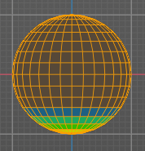
Extrusion 3D printers have a physical limit to the overhang that can be printed. Overhang mode shows the overhang. Angle and axis can be adjusted.

Minimum/Maximum
Minimum/Maximum angle to display.

Axis
Choose which angle to calculate.

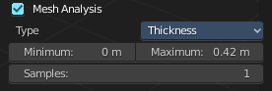
Thickness
3D Printers have a limited wall-thickness. Too thin areas cannot be printed. This mode displays thin areas as red.

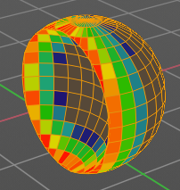
Minimum/Maximum
Minimum/Maximum thickness to display.

Samples
The number of samples to use to calculate the thickness.

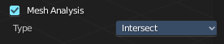
Intersections
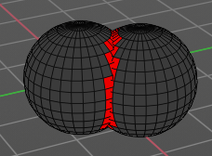
A mesh can be made of more than one closed sub mesh. Join two spheres and you have one mesh with two closed sub meshes. Such intersections can be a problem with printing. Intersect marks intersecting areas with red.

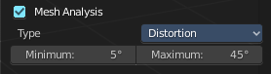
Distortion
Marks distorted faces.
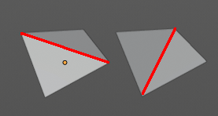
Distorted geometry, means uneven quads or N-gons, can cause problems with printing. Since the triangulation of a distorted quad or N-gon is undefined. And printing works with tris. With a quad there are already two solutions in which direction the edge to triangulate the face can point.

Minimum/Maximum
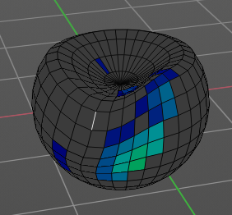
Adjust the minimum and maximum values after which a face gets displayed as distorted.

Sharp Edges
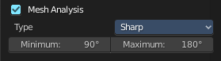
Similar to wall-thickness, sharp edges can be too thin to be able to print.

Minimum/Maximum
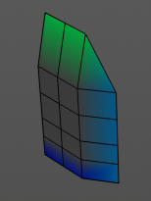
Adjust the minimum and maximum values after which an edge gets displayed as sharp.

Measurement
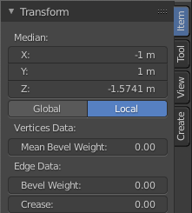
Shows measure values at the selected elements. The units are displayed as chosen in the preferences. These values respects global/ local in the transform panel. And so the values can differ when you have scaled the mesh in object mode, and the scaling is not applied yet. Use Global to take the object scale into account.

Edge Length
Shows the length of selected edges.

Edge Angle
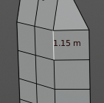
Shows the angle of selected edges between two faces.

Face Area
Show the area of selected faces.

Face Angle
Show the angle of selected face corners.

Normals
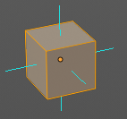
Show the normals for the chosen elements. They will be displayed as lines.
Display vertex normals
Display face normals at vertices (split normals)
Display face normals

Size
Adjust the length of the line that represents the normal.

Freestyle
Freestyle is the line renderer integrated into Bforartists. For freestyle you can mark edges and faces.

Edge Marks
Display Freestyle edge marks, used with the Freestyle renderer.

Face Marks
Display Freestyle face marks, used with the Freestyle renderer.

Show Overlays - Mesh Object - Sculpt Mode

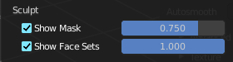
Show Mask
Show mask as overlay on object. The opacity of the overlay can be controlled by the slider.

Show Face Sets
Show face sets as overlay on object. The opacity of the overlay can be controlled by the slider.

Show Overlays - Mesh Object - Vertex Paint Mode

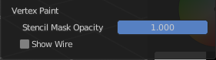
Opacity
How strong the painted color gets shown.

Show Wire
Display the wire at the mesh. Normally the wire is hidden.

Show Overlays - Mesh Object - Weight Paint Mode

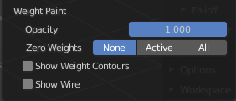
Opacity
The opacity of the color overlay.

Zero Weights

None
Don't show the vertices with zero weights with a specific color. They appear blue like vertices with a very low weighting.

Active
Zero weights vertices are shown with a black color in the active vertex group.

All
Zero weights vertices are shown with a black color in all vertex groups of the mesh.

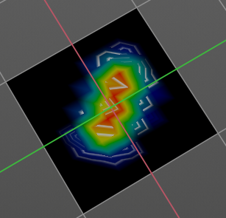
Show Weight Contours
Show contour lines formed by points with the same interpolated weight.

Show Wire
Display the wire at the mesh. Normally the wire is hidden.

Show Overlays - Mesh Object - Texture Paint Mode

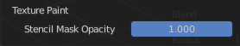
Stencil Opacity
How strong the painted color gets shown.

Show Overlays - Pose Mode

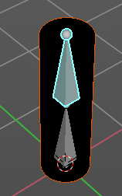
Show Bone X Ray
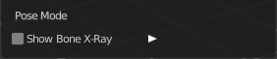
This has in general nearly the same effect than draw in front. It shows the bones on top of the mesh geometry. But you can fade the mesh geometry to black.


Opacity
The opacity of the object in the background.

Show Overlays - Grease Pencil

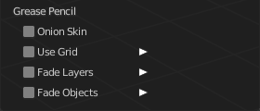
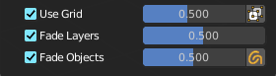
In Object Mode

Onion Skin
Show ghosts of the key frames before and after the current frame.

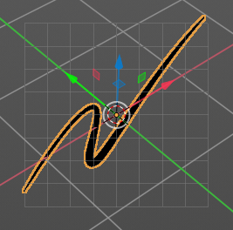
Canvas
Display a grid over Grease Pencil drawing plane. The opacity of the grid can be controlled with a slider.

Canvas X Ray
Show the grid in front of the stroke.

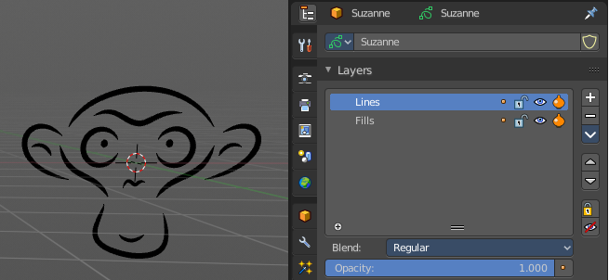
Fade Layers
Controls the opacity of the not selected layers in the current grease pencil object.

I have set the fade layers opacity to 1 here. When you select the other layer, then the inner part becomes visible again, and the black outlines hides.

Fade Objects
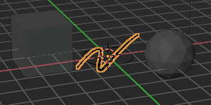
Fades everything in the viewport but the grease pencil color to black.

Fade Grease Pencil Objects
Fades the not active grease pencil objects to black too.

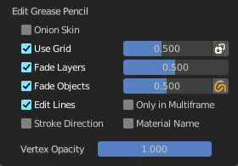
In Edit Mode

Onion Skin
Show ghosts of the key frames before and after the current frame.

Canvas
Display a grid over Grease Pencil drawing plane. The opacity of the grid can be controlled with a slider.

Canvas X Ray
Show the grid in front of the stroke.

Fade Layers
Control the opacity of the not selected layers in the current grease pencil object.

I have set the fade layers opacity to 1 here. When you select the other layer, then the inner part becomes visible again, and the black outlines hides.

Fade Objects
Fades everything in the viewport but the grease pencil color to black.

Fade Grease Pencil Objects
Fades the not active grease pencil objects to black too.

Edit Lines
Show the edges of the curve when editing strokes.

Stroke Direction
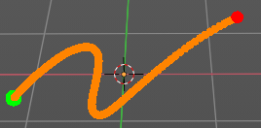
Shows a red and a green dot at the end of the stroke. Green dot is start. Red dot is end.

Only in multi frame
Only show edges of the curve while in multi frame edition.

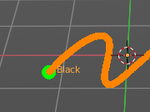
Material Name
Displays the material name at the start of the stroke.

Vertex Opacity
How strong the selected vertices of the stroke shows.

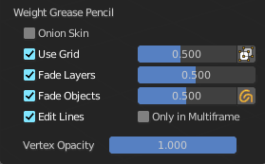
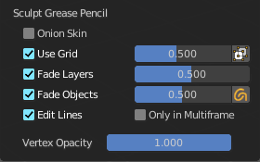
In Sculpt and Weight paint Mode

Onion Skin
Show ghosts of the key frames before and after the current frame.

Canvas
Display a grid over Grease Pencil drawing plane. The opacity of the grid can be controlled with a slider.

Canvas X Ray
Show the grid in front of the stroke.

Fade Layers
Control the opacity of the not selected layers in the current grease pencil object.

I have set the fade layers opacity to 1 here. When you select the other layer, then the inner part becomes visible again, and the black outlines hides.

Fade Objects
Fades everything in the viewport but the grease pencil color to black.

Fade Grease Pencil Objects
Fades the not active grease pencil objects to black too.

Edit Lines
Show the edges of the curve when editing strokes.

Only in multi frame
Only show edges of the curve while in multi frame edition.

Vertex Opacity
How strong the selected vertices of the stroke shows.

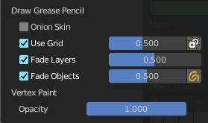
In Draw Mode

Onion Skin
Show ghosts of the key frames before and after the current frame.

Canvas
Display a grid over Grease Pencil drawing plane. The opacity of the grid can be controlled with a slider.

Canvas X Ray
Show the grid in front of the stroke.

Fade Layers
Control the opacity of the not selected layers in the current grease pencil object.

I have set the fade layers opacity to 1 here. When you select the other layer, then the inner part becomes visible again, and the black outlines hides.

Fade Objects
Fades everything in the viewport but the grease pencil color to black.

Fade Grease Pencil Objects
Fades the not active grease pencil objects to black too.

Vertex Opacity
How strong the selected vertices of the stroke shows.

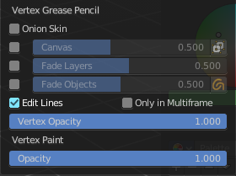
In Vertex Paint mode

Onion Skin
Show ghosts of the key frames before and after the current frame.

Canvas
Display a grid over Grease Pencil drawing plane. The opacity of the grid can be controlled with a slider.

Canvas X Ray
Show the grid in front of the stroke.

Fade Layers
Control the opacity of the not selected layers in the current grease pencil object.

I have set the fade layers opacity to 1 here. When you select the other layer, then the inner part becomes visible again, and the black outlines hides.

Fade Objects
Fades everything in the viewport but the grease pencil color to black.

Fade Grease Pencil Objects
Fades the not active grease pencil objects to black too.

Edit Lines
Show the edges of the curve when editing strokes.

Only in multi frame
Only show edges of the curve while in multi frame edition.

Vertex Opacity
How strong the selected vertices of the stroke shows.

Opacity
The vertex paint opacity.

Viewport Shading

At the very right of the header you can find the viewport shading settings. Here you adjust the display of the viewport. The order goes from left to right.

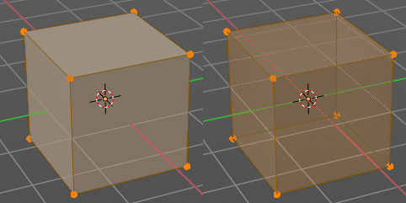
Show X Ray
This viewport setting is connected with the viewport shading. It allows you to show and edit the back geometry. Or hide it, so that you can just edit the geometry that points forwards.

Viewport Shading
Defines how geometry gets displayed in the viewport.

Wire frame
Displays the content in the viewport as Wire frame.

Solid
Displays the content in the viewport with a solid white color.

Material
Displays the content in the viewport with all material settings and with OpenGL rendering. Note that this does not exist when you choose the Workbench renderer.

Rendered
Displays the content in the viewport like you would have rendered it. This mode is dependent of what render engine you have currently active.

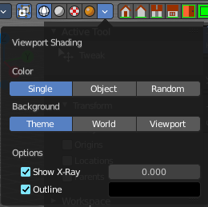
Viewport Shading Settings
The viewport shading panel. Its settings changes, dependent of which viewport shading mode you have activated. And provides you with further settings for it.

Viewport Shading Settings with Wire frame

Color

Single
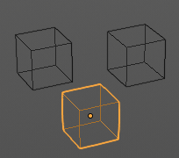
The selected object gets highlighted. The wire frame is the color of the selection outline. The not selected objects shows a black wire frame.

Object
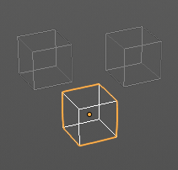
The selected object gets highlighted. The wire frame is white. The not selected objects shows a Grey wire frame.

Random
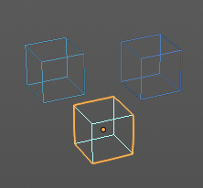
The selected object gets highlighted. The wire frame is a random wire frame color. The not selected objects shows a random wire frame color. You cannot influence this random color. It is random.

Background

Theme
Uses the viewport background color as defined in the theme.

World
Uses the world background color as the viewport background color.

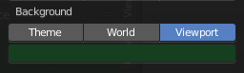
Viewport
Defines a custom color for the viewport background color.

Options

Show X Ray
This viewport setting is connected with the viewport shading. It allows you to show and edit the back geometry. Or hide it, so that you can just edit the geometry that points forwards.

X Ray Alpha
Adjust the amount of transparency.

Outline
Show the not selected objects with an outline.

Outline Color
Defines the color of the outline for not selected objects.

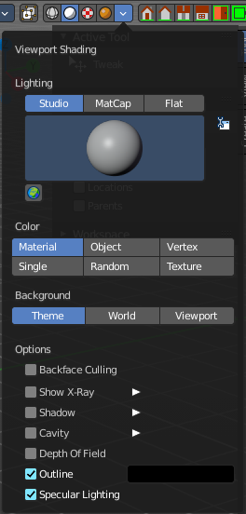
Viewport shading Settings with Solid

Lighting
Choose between different lighting methods.
Note that this methods are not for rendering the scene. This lighting methods are meant to light the viewport.

Studio
Uses a studio setup lighting. You can choose between several studio light setups in the library menu below. This library menu is a box with a preview of the currently active light setup.
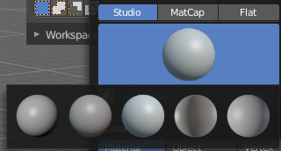

World Space Lighting
Make the lighting fixed to the world. And not follow the camera when you rotate around the scene.

Rotation
The rotation of the light setup. This edit box is just active when you use World Space Lighting.

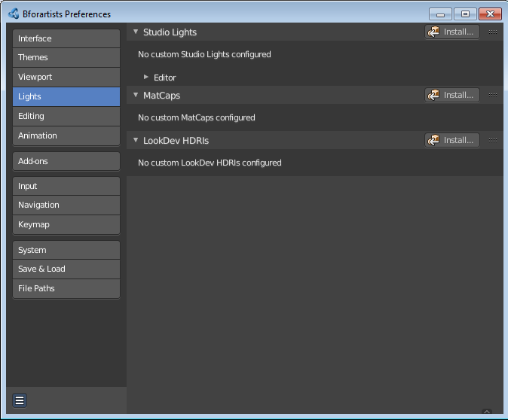
Show Light Preferences
At the right of the drop down box you will see a tiny button. It will open the preferences, where you can edit the existing studio light setups, or add new Studio light setups. This chapter is explained in the preferences manual part.

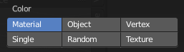
Color
Influence how the objects in the scene are colored. Just one setting can be active at one time.

Material
Uses the color of the material, in case a material is assigned to the object(s).

Object
Uses the Object color.

Vertex
Shows the vertex colors in case vertex colors exists.

Single
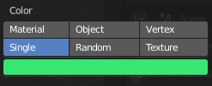
Define a custom color. A color picker box appears when you activate single.

Random
Colors the objects with a random color

Texture
Shows the texture in case a material with a texture is assigned to the object(s).

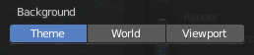
Background
Define the look of the viewport background

Theme
Uses the background as defined in the theme.

World
Uses the background as defined in the world settings of the scene.

Viewport
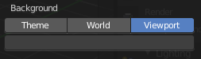
Use a custom color. When you activate this setting, then a color picker field appears, adjust a custom color.

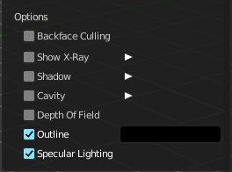
Options

Back face Culling
Use back face culling to hide backsides of faces.

Show X Ray
This viewport setting is connected with the viewport shading. It allows you to show and edit the back geometry. Or hide it, so that you can just see and edit the geometry that points forwards.
Note that you can either have Show X Ray active. Or Shadow and Cavity.

X Ray Alpha
Adjust the strength of the transparency effect.

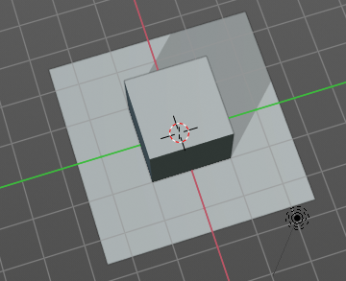
Shadow
Cast a shadow. Note that the shadow casting light is not part of the chosen studio light. It is an independent light.

Shadow Intensity
Here you adjust the strength of the shadow. Higher value means darker shadow.

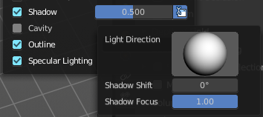
Light Settings
Adjust some settings of the light.

Light Direction
Click into the field and drag the mouse to change the direction of the light that casts the shadow.

Shadow Shift
The shadow termination angle. This can be used to minimize self shadowing artifacts.

Shadow Focus
The shadow hardness. It controls the falloff near the edge of the shadow.

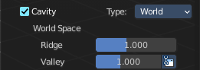
Cavity
Show Cavity. Cavity highlights ridges and valleys in the scene geometry. When you activate this setting, then further settings appears.

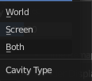
Type
The method how to calculate the cavity. In worlds pace, in screen space. Or in both.

World
Draw the cavity shading in world space.

World Space / Ridge Valley
Factor for the cavity ridges and valleys.

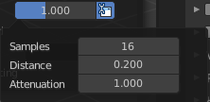
Shading Options
Adjust samples, distance and attenuation for the cavity ridges and valleys.

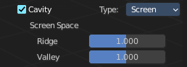
Screen
Draw the cavity shading in Screen space.

Screen Space / Ridge Valley
Factor for the curvature ridges and valleys.

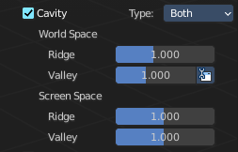
Both
Draw the cavity shading in both, World Space and Screen space.
Settings see above.

Depth of Field
Use depth of field for the viewport. It uses the values from the active camera.

Outline
Show the not selected objects with an outline.

Outline Color
Define the color of the outline for not selected objects.

Specular Lighting
Render specular highlights.

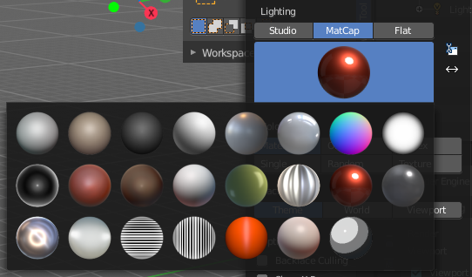
Matcap
Matcap stands for material capture. With Matcap you use a special matcap shader at the mesh. This shader is usually something colorful, which makes for example sculpting easier.
You can choose between several matcap setups in the library menu below. This library menu is a box with a preview of the currently active matcap setup.

Show Light Preferences
At the right of the library menu box you will see a tiny button. It will open the preferences, where you can edit the existing studio light setups, or add new Studio light setups. This chapter is explained in the preferences manual part.

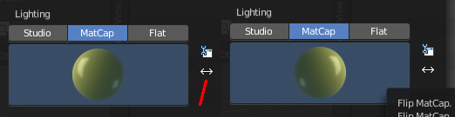
Flip Matcap
Some matcaps have a direction from which the light comes. With Flip Matcap you can flip this direction.

Color
Influence how the objects in the scene are colored. Just one setting can be active at one time.

Material
Uses the color of the material, in case a material is assigned to the object(s).

Object
Uses the Object color.

Vertex
Shows the vertex colors in case vertex colors exists.

Single
Define a custom color. A color picker box appears when you activate single.

Random
Colors the objects with a random color

Texture
Shows the texture in case a material with a texture is assigned to the object(s).

Background
This defines the look of the viewport background

Theme
Uses the background as defined in the theme.

World
Uses the background as defined in the world settings of the scene.

Viewport
Use a custom color. When you activate this setting, then a color picker field appears, adjust a custom color.

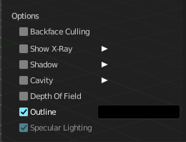
Options

Back face Culling
Use back face culling to hide backsides of faces.

Show X Ray
This viewport setting is connected with the viewport shading. It allows you to show and edit the back geometry. Or hide it, so that you can just see and edit the geometry that points forwards.

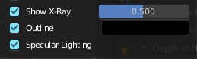
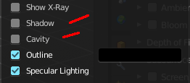
Note that you can either have Show X Ray active. Or Shadow and Cavity. When activating Show X Ray, the other two options will be hidden.

X Ray Alpha
Adjust the strength of the transparency effect.

Shadow
Cast a shadow. Note that the shadow casting light is not part of the chosen studio light. It is an independent light.

Shadow Intensity
Here you adjust the strength of the shadow. Higher value means darker shadow.

Light Settings
Adjust some settings of the light.

Light Direction
Click into the field and drag the mouse to change the direction of the light that casts the shadow.

Shadow Shift
The shadow termination angle. This can be used to minimize self shadowing artifacts.

Shadow Focus
The shadow hardness. It controls the falloff near the edge of the shadow.

Cavity
Show Cavity. Cavity highlights ridges and valleys in the scene geometry. When you activate this setting, then further settings appears.

Type
The method how to calculate the cavity. In worlds pace, in screen space. Or in both.

World
Draw the cavity shading in world space.

World Space / Ridge Valley
Factor for the cavity ridges and valleys.

Shading Options
Adjust samples, distance and attenuation for the cavity ridges and valleys.

Screen
Draw the cavity shading in Screen space.

Screen Space / Ridge Valley
Factor for the curvature ridges and valleys.

Both
Draw the cavity shading in both, World Space and Screen space.
Settings see above.

Outline
Show the not selected objects with an outline.

Outline Color
Define the color of the outline for not selected objects.

Specular Lighting
Render specular highlights.

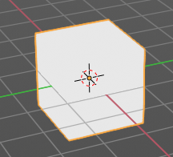
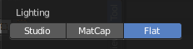
Flat
Lights the objects plain white.

Color
Influence how the objects in the scene are colored. Just one setting can be active at one time.

Material
Uses the color of the material, in case a material is assigned to the object(s).

Object
Uses the Object color.

Vertex
Shows the vertex colors in case vertex colors exists.

Single
Define a custom color. A color picker box appears when you activate single.

Random
Colors the objects with a random color

Texture
Shows the texture in case a material with a texture is assigned to the object(s).

Background
Define the look of the viewport background.

Theme
Uses the background as defined in the theme.

World
Uses the background as defined in the world settings of the scene.

Viewport
Use a custom color. When you activate this setting, then a color picker field appears, adjust a custom color.

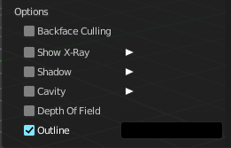
Options

Back face Culling
Use back face culling to hide backsides of faces.

Show X Ray
This viewport setting is connected with the viewport shading. It allows you to show and edit the back geometry. Or hide it, so that you can just see and edit the geometry that points forwards.

Note that you can either have Show X Ray active. Or Shadow and Cavity. When activating Show X Ray, the other two options will be hidden.

X Ray Alpha
Adjust the strength of the transparency effect.

Shadow
Cast a shadow. Note that the shadow casting light is not part of the chosen studio light. It is an independent light.

Shadow Intensity
Here you adjust the strength of the shadow. Higher value means darker shadow.

Light Settings
Adjust some settings of the light.

Light Direction
Click into the field and drag the mouse to change the direction of the light that casts the shadow.

Shadow Shift
The shadow termination angle. This can be used to minimize self shadowing artifacts.

Shadow Focus
The shadow hardness. It controls the falloff near the edge of the shadow.

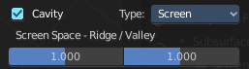
Cavity
Show Cavity. Cavity highlights ridges and valleys in the scene geometry. When you activate this setting, then further settings appears.

Type
The method how to calculate the cavity. In worlds pace, in screen space. Or in both.

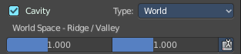
World
Draw the cavity shading in world space.

World Space / Ridge Valley
Factor for the cavity ridges and valleys.

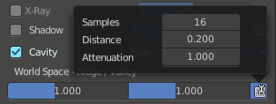
Shading Options
Adjust samples, distance and attenuation for the cavity ridges and valleys.

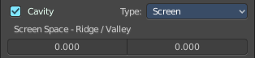
Screen
Draw the cavity shading in Screen space.

Screen Space / Ridge Valley
Factor for the curvature ridges and valleys.

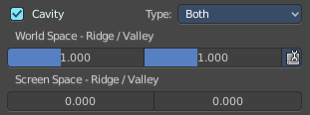
Both
Draw the cavity shading in both, World Space and Screen space.
Settings see above.

Outline
Show the not selected objects with an outline.

Outline Color
This defines the color of the outline for not selected objects.

Specular Lighting
Render specular highlights.

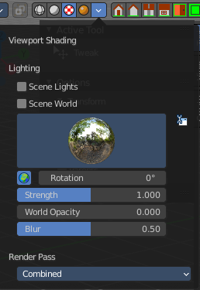
Viewport Shading with Material Preview
In this mode you can use a hdr file to light the scene.
This mode is just available with Cycles and Eevee renderer. Workspace renderer does not have this mode.

Lighting

Scene Lights
Use the scene lights instead of the hdr to light the scene.

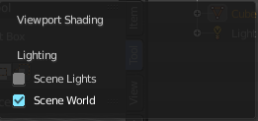
Scene World
Use the scene world to light the scene. This turns off the hdr. And the further options are not longer available.

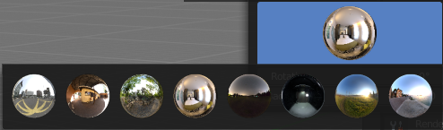
hdr file browser
Pick a hdr file to light the world with.

Show light preferences
At the right of the library menu box you will see a tiny button. It will open the preferences, where you can edit the existing studio light setups, or add new Studio light setups. This chapter is explained in the preferences manual part.

World Space Lighting
Make the hdr rotation fixed, and not follow the camera.

Rotation
The rotation of the hdr file.

Background
Show the studio light in the background. The higher the value the more the studio light gets mixed into the hdr.

World Opacity
Show the studio light in the background

Blur
The blur factor.

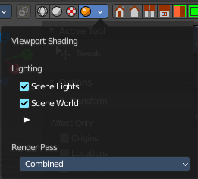
Viewport Shading with Rendered
With rendered shading the viewport uses the renderer settings of the chosen render engine. Workbench has no specific shading settings here. And the panel is empty. Cycles and Eeevee have some further settings.

Lighting

Scene Lights
Render lights and light probes in the scene.

Scene World
Use scene world for lighting. When you turn off Scene World then you reveal further settings.

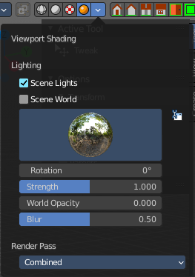
Studiolight Preview
Displays the current active hdri file to light the scene. A click at the display allows you to pick another hdri file.
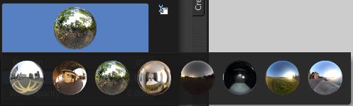

Show Light preferences
Opens the light preferences in the preferences where you can pick more hdri files.

Rotation
The rotation of the studio light.

Strength
The strength of the studio light.

World Opacity
The opacity of the hdri.

Blur
Eevee. Blur the studiolight in the background.

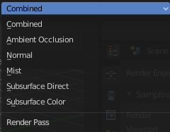
Render Pass
Choose what render passes to calculate.

Pause Preview
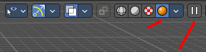
When you choose the Cycles renderer and set the viewport shading mode to rendered, then it reveals one more button at the right. Pause Preview pauses the rendering in the viewport when Cycles is chosen as the viewport renderer.

Align View Buttons

Align View Buttons
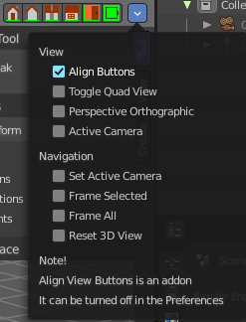
Align View Buttons is an addon. The buttons allows you to align the view to the orthographic views. And brings further functionality from the View menu. The content is all a double entry by purpose, to have these buttons at the top hierarchical position for quick access.
This addon can be turned off in the Preferences.

Grease Pencil - all modes - Layer Panel

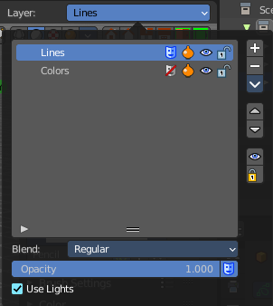
This panel shows in most of the modes. It is the same content than the Layers panel in the Object Data Properties.

Layer list

Layer name
The name of the layer.

Mask Layer
Toggle the Masks visibility in the layer.

Onion Skinning
Toggle the use the layer for Onion Skinning.

Viewport/Render Visibility
Toggle layer visibility in the viewport and in render.

Lock
Toggle layer from being editable.

Search Field
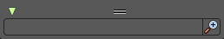
You can expand a search field at the bottom of the list. Type in your term and hit enter to filter for your term.

Add new layer
Adds a new layer.

Remove layer
Removes the selected layer.

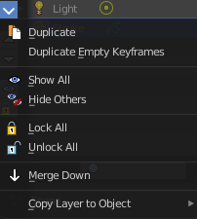
Layer Specials

Duplicate Layer
Makes an exact copy of the selected layer appending a number to differentiate its name.

Duplicate Empty Keyframes
Makes a copy of the active grease pencil layer.

Show All
Turns on the visibility of every layer in the list.

Hide Others
Turns off the visibility of every layer in the list except the active one.

Lock All
Locks edition of all the layers in the list

Unlock All
Unlocks edition of all the layers in the list.

Autolock inactive layer
Locks automatically the edition of every layer in the list except the active one. This way you avoid to make unwanted changes in other layers without the need to lock them every time.

Merge Down
Merge the selected layer with the layer below, the new layer keeps the name of the lower layer.

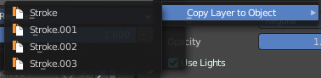
Copy Layer to Object
Makes a copy of the layer and move it to the selected Grease Pencil object.

Isolate Layer
Hide and lock the layer.

Isolate Layer
Lock the layer.

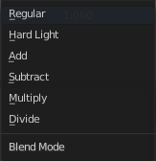
Blend
The layer blending operation to perform. See Color Blend Modes.

Opacity
Used to set the opacity of the layer.

Use Lights
When enabled, the layer is affected by lights.

Grease Pencil - Edit mode - Options Panel

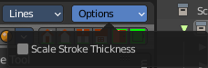
Scale Stroke Thickness
Scale the stroke thickness when transforming strokes.

